Data on Global Culture Types (Guilt, Shame, Fear)

by Jayson Georges

Jan 15, 2014

In the last three months, over 1,200 people have taken The Culture Test. Here is a summary of the data.

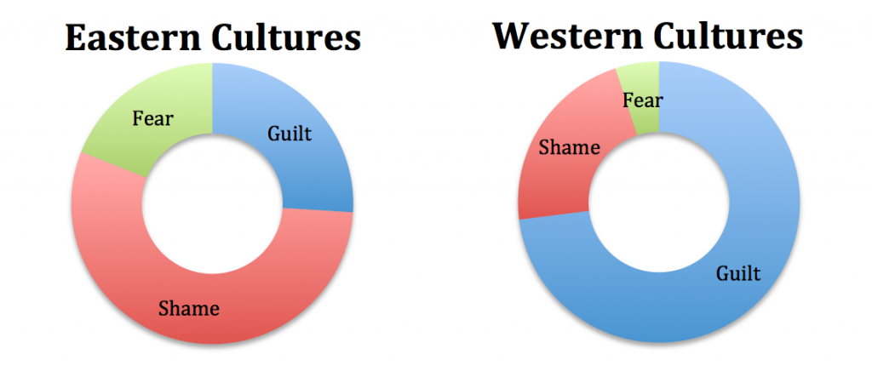
The following bar graph breaks down the results by global regions.
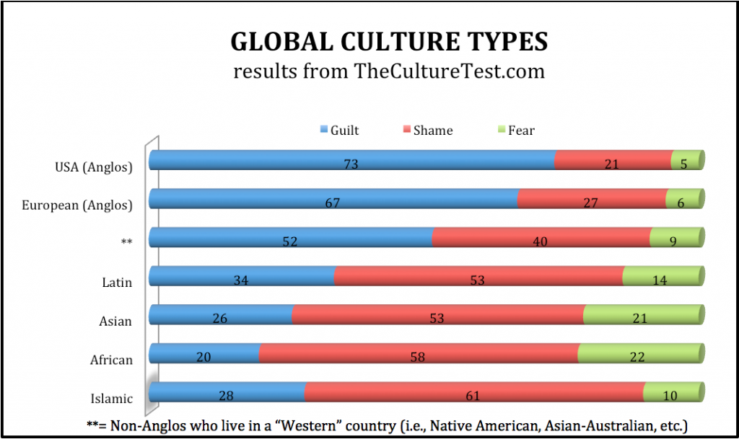
But that is not the entire story. To understand the predominance of honor/shame cultures globally, we must account for the population size. The length of each bar in the below graph reflects the population of that region.
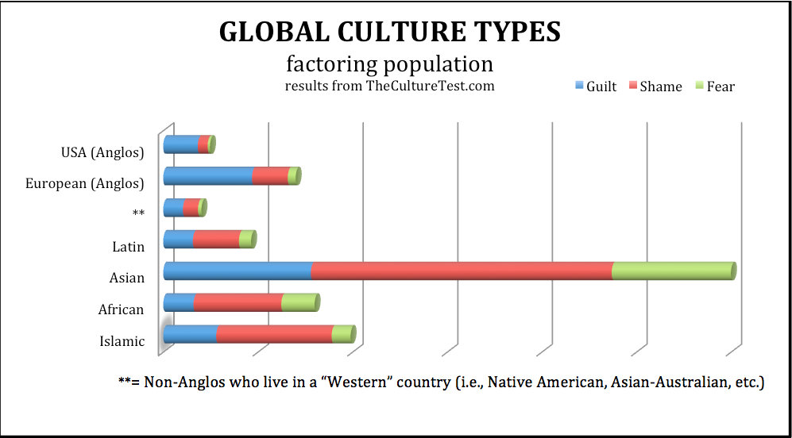

Some Observations
- Americans and Europeans feel guilty, the rest of the world feels shameful…I mean, Westerners feel innocent and Easterners feel honorable.
- European-Anglos are slightly more influenced by shame/honor than American-Anglos. This is primarily because of results from the Latin/Mediterranean cultures of southern Europe, such as Portugal and Spain.
- Asians and Africans have the highest score on fear, 21% and 22% respectively.
- When non-Caucasians move to a Western country (** on the chart), they become more guilt-oriented and less shame-oriented.
- Latins are the most “balanced” culture (or, “the hardest to figure out!”).
- Africans are the least guilt-based.
- Muslims are the most shame-based.
- Globally, shame-based cultures are the most prevalent. For this reason a biblical theology for honor/shame cultures is missiologically imperative.
- Finally, none of the data was completely surprising (at least to me). But it is helpful to confirm what missiologists have generally suspected.

Two Qualifications
- This data is based on just over 1,000 results, which I consider a rather small sample size for analyzing global cultures. As more people learn their culture type, we’ll be able to provide much more accurate data, and account for other variables (i.e., age, gender, education, etc.). So, let others know about The Culture Test, and make use of it in your training ministry.
- TheCultureTest.com is foremost a training/learning tool; research is a secondary purpose. So I designed the survey to be accessible and engaging, not thorough and exhaustive. Nevertheless, there are trends which we can trace for missiological purposes, as I began to note above.

